| No. of Pages | **7** |
| --- | --- |
| No. of Questions | 7 |

**Department of Computer Science and Engineering**

**FINAL EXAMINATION SPRING 2017**

**CSE421/EEE 465: Computer Networks**

**Total Marks: 100 Time Allowed: 2.5 Hours**



* Answer **Any** **Five (5)** questions out of **Seven (7)** questions.
* Figure in bracket [] next to each question indicates marks for that question.



###### Question No. 1

1. There are three routers R1, R2, R3 in a network. What will happen after 70 seconds, 190 seconds, and 250 seconds, if R1 does not receive any RIP updates from R2 after the first update? [6 Marks]
2. What will happen if the following commands are given to a router? [4 Marks]  
   **R1(config) # router rip**

**R1(config-router) # passive-interface Serial0/0/0**

1. There are two routing protocols with the administrative distances of 110 and 120 respectiviely. Which one will be chosen? Why? [4 Marks]

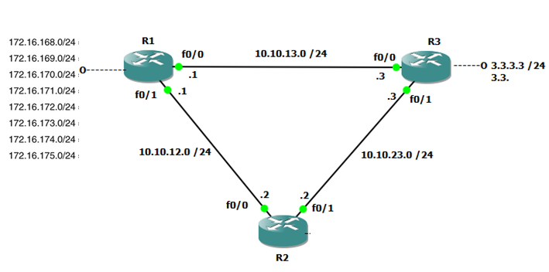

1. Router R1 is connected to the following networks shown in **figure no.1.** What will be the summarized address to represent all 8 addresses, if you wish to manually summarize? What will be the summarized address if auto-summary is on in Router R1? [6 Marks]

**Question No. 2**

###### There are three routers A, B and C with hello intervals of 30 seconds, 10 seconds and 30 seconds respectively. Can they form OSPF adjacency with each other? Explain your opinion. [3 Marks]

1. In the topology of **figure no. 2**, you implemented OSPF protocol and discovered that the traffic is so high that the network is jammed. You also identified that most of the packets are LSA packets. What can be the cause? How can you solve it? [3+4Marks] 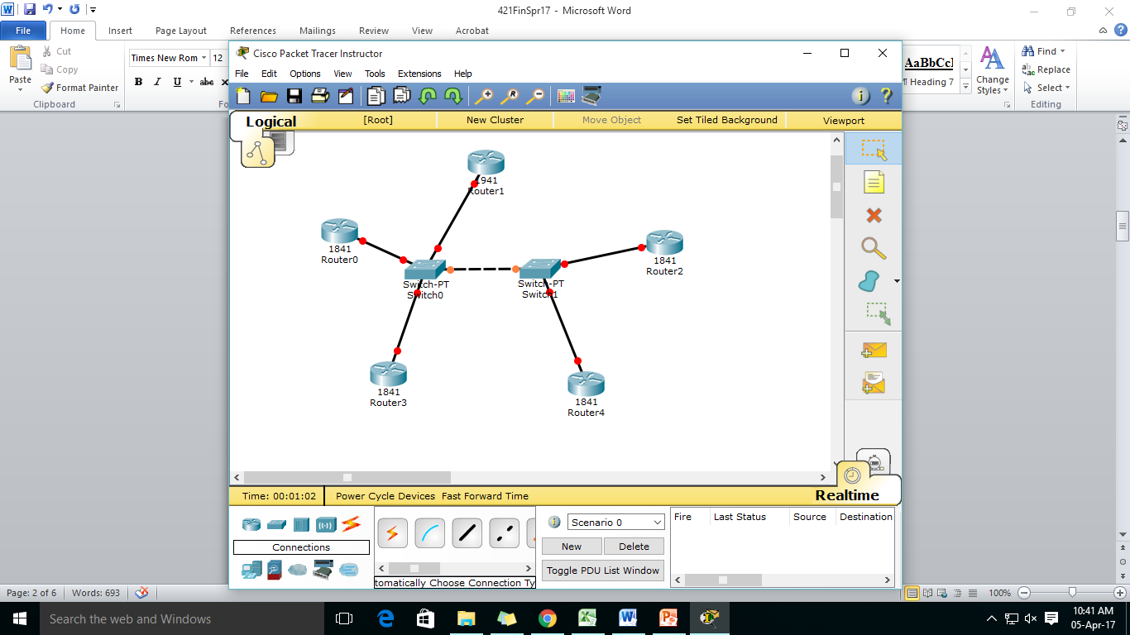  
   
2. What are the tables stored in the routers if OSPF is implemented in the network? What data is stored in each of those tables? [6 Marks]
3. If the following command “**ip ospf cost 392**”is given to a router, what will be bandwidth of the associated link? [4 Marks]

###### Question No. 3

1. Assume that the DF flag of a IPv4 datagram is set to 0. If the size of a datagram is 1700 and the MTU of the link is 4800, will you perform fragmentation? If yes, show the fragmentation. If no, explain why. [6 Marks]
2. What is the default lease time for DHCP clients? Can you change it? If yes, write the command to change the lease time to 3 days. [2+2 Marks]
3. Assume that the source address and port of three devices in your inside network is given as **table 1**. The inside global address is 192.168.1.5 and outside global address is 256.128.2.11. Show the NAT table for the scenario. [4 Marks]

***Table 1***

| Source Address | Port Number |
| --- | --- |
| 10.2.10.10 | 1552 |
| 10.2.10.3 | 1552 |
| 10.2.10.5 | 1332 |

1. Show the steps of traceroute operation from routers Branch to ISP using **figure no. 3**. [6 Marks]  
    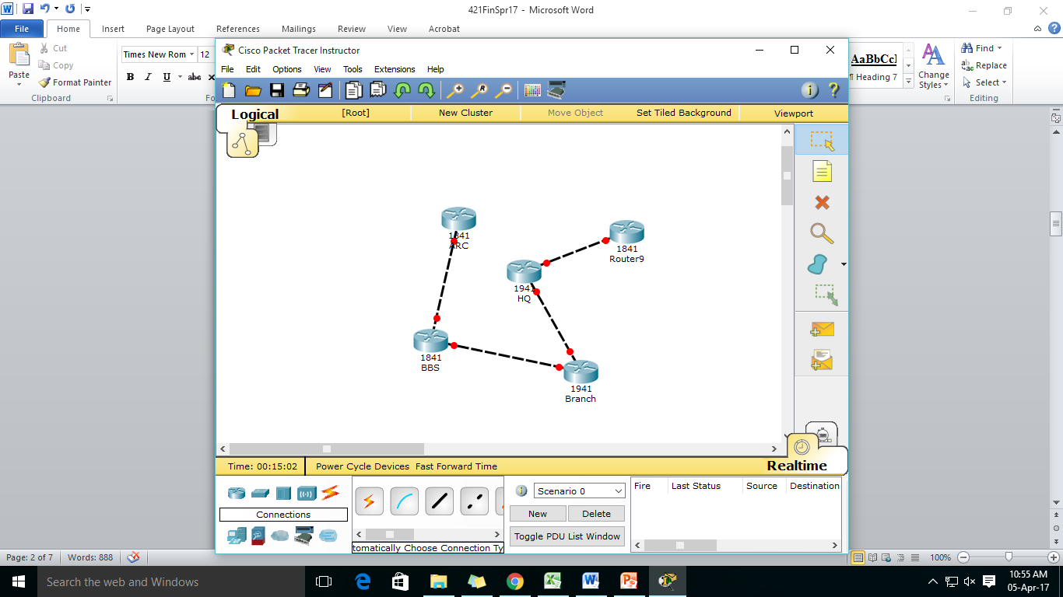

###### Question No. 4

1. Which of the following IPV6 address representations are correct and which are not? If incorrect, explain why?  
   1. **2A34::0045:BA1:0**

2. **::**  
3. **1A34::3:B1::2C** [6 Marks]

1. If you are given a MAC address of 214B:3124:CA10, what will be the IPV6 address derived from it using EUI-64? Show the calculation steps. [5 Marks]
2. What is stateless address auto-configuration? Is it possible to perform DHCP spoofing attack if this auto-configuration method is used? [4 Marks]
3. What is IPV6 tunneling? How does it work? [5 Marks]

###### Question No. 5

1. Refer to **figure no.4** .Why the switch has no information regarding port 2 and 4? What happens when PC2 sends a frame to PC1? [2+3 marks]
2. Differentiate between Fragment Free and Store and Forward switching? Why is 64 bytes important for Fragment Free switching? [3+2 marks]

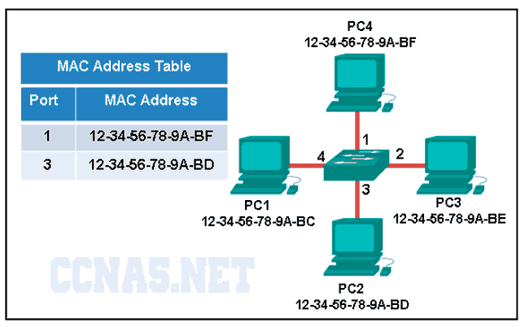

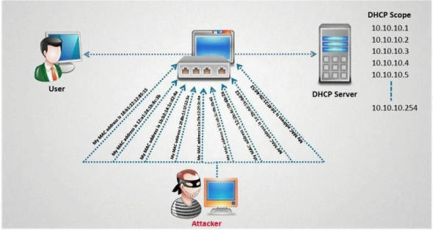



1. Refer to the above **figure no.5** . The attacker is sending multiple dhcp discover requests as shown. What will happen if he keeps sending such packets? How can we prevent this from happening? [4 marks]
2. Refer to the above commands shown in **figure no.6** . Is the switchport fa0/1 up and running? Explain why yes or no. And if no then how can we make the port fa0/1 up? [4+2 marks]

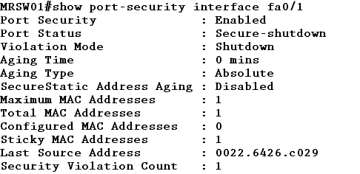



###### Question No. 6

1. Differentiate between the following two commands [3 marks]
   1. S1(config-if)# no switchport access vlan 20
   2. S1(config)# no vlan 20

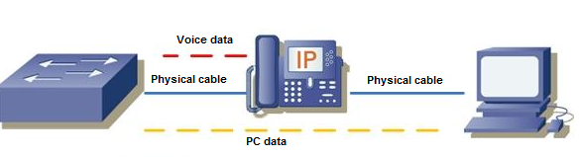



1. Refer to the **figure no. 7** above, data vlan is VLAN10. Where do we tag PC data and Voice data? How does the switch know that voice needs to be prioritized? [4 marks]
2. What is the effect of writing and not writing the following command “**switchport allowed vlan 10,20,30**” ? [3 marks]
3. Why is “Router on a Stick” is better than “Traditional” Inter VLAN routing? [3 marks]
4. Refer to the commands and topology shown in **figure no.8 &9** , [3+4 marks]
   1. Host 1 and Host 2 have no connectivity, why?
   2. If the administrator wants you to add a new VLAN 40, what steps do you need to take?



###### 

###### 

###### 

###### Question No. 7

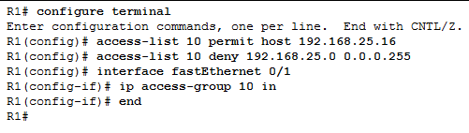



1. Referring to the above **figure no. 10**, the administrator wants now you to permit the IP address 192.168.25.20 instead of 192.168.25.16. How will you do it? Explain in steps or use commands. [3 marks]

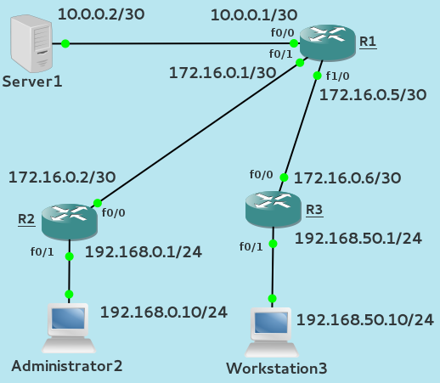

1. Referring to the above **figure no.11**, write a named standard ACL that will allow both the 192.168.0.0/24 and 192.168.50.0/24 networks to access the Server 1(10.0.0.2). No other networks can access the Server1. Remember to mention which router you are writing the ACL and also place the ACL at the appropriate interface of the router. [6 marks]
2. Refer to **figure no. 11**, write a standard ACL that will only allow Administrator2 PC to telnet into the Router R1. [4 marks]

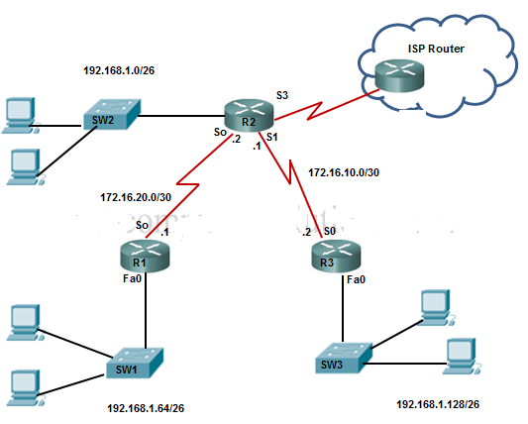



1. Refer to **figure no. 12**, write a named extended ACL in ISP that will
2. Hosts of 192.168.128.0/26 and 192.168.64.0/26 can have web access to anywhere but not hosts from 192.168.1.0/26. do not have any kind of access to the outside world.
3. And also allow only established responses back from the Internet.

[Do not forget to place the ACLs appropriately at appropriate routers.] [7 marks]



##### THE END